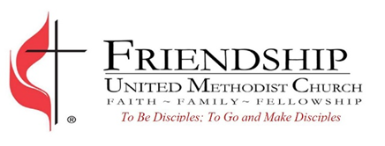
Communications Coordinator
Position:
Part-time Hybrid Hourly Position, estimated $20-25 an hour
Expected Hours: 10-15 hours a week
In office hours for weekly meetings and special events

Accountable to: Senior Pastor
Job Summary:
The Communications Coordinator organizes and manages church communications and develops strategies to connect the congregation with the wider community. It is critical to be team-oriented, collaborative, and embrace the inclusive mission and values of Friendship UMC. Needs to have a calling and vision to explore new ways to communicate ministries in creative ways to the congregation and wider community.

Communications Responsibilities:
- Develop and implement communications and marketing strategies to connect the congregation with the wider community
- Organize and manage all church communications, including but not limited to website, social media, and email newsletter
- Create content for social media and manage ongoing website development and updates
- Design bulletins and flyers in coordination with congregation and staff
- Attend in-person meetings with staff as needed to coordinate communications priorities
- Performs other duties as may be requested or required by the Pastor

Qualifications and Skills:
- Must have previous communications experience, preferably in a church environment.
- Proficient in website design/development, social media platforms, and Canva
- Proficient in MS Office
- Excellent verbal and written communication skills
- Flexible and adaptable to a changing ministry environment
- Must be compassionate and attentive to the needs of staff, church members, and visitors
- Willingness to learn and sharpen skills

